Biology, Castle View High School  
Jason R Mayberry

**Study Guide: Proteins**

**Vocabulary**

1. Amino Acid
2. Polypeptide
3. Protein
4. Active Site
5. Coenzymes/Vitamins
6. Negative Feedback
7. Competitive Binding

**Short Answer/Conceptual Questions**:

1. Summarize the cellular functions of proteins.
2. What makes one amino acid different from another?
3. Draw a basic hydrophobic amino acid? Draw a basic hydrophilic amino acid?
4. Describe how amino acids are joined together; draw several amino acids thus linked together.
5. Describe how the sequence of amino acids of different types causes a protein to fold into a specific shape.

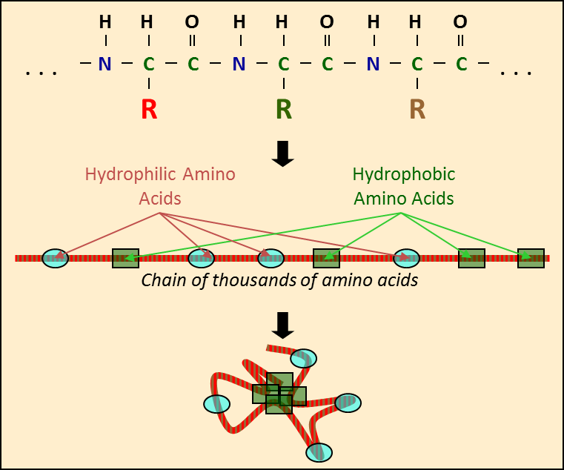

1. Describe the types of bonds that are involved in making and folding a protein

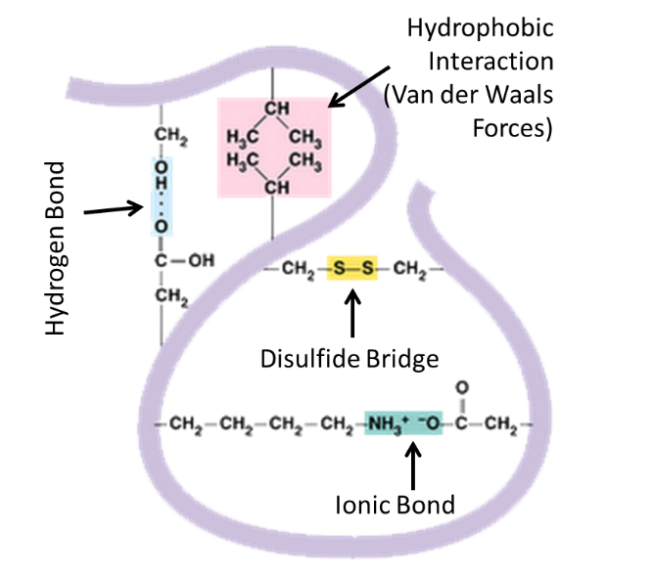

1. Describe the relationship between a proteins shape and its function.
2. Describe a general ***mechanism of action*** for how an enzyme could catalyze the condensation of two monomers.

